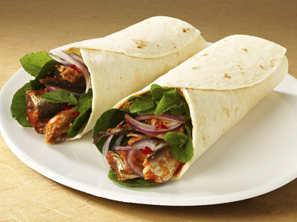

**The 14 Best Places for Wraps and Rolls in Udaipur**

[](https://www.udaipurblog.com/author/akshat)

by [Akshat Khamesra](https://www.udaipurblog.com/author/akshat)1 year ago1 year ago

* [Facebook](https://www.facebook.com/sharer/sharer.php?u=https://www.udaipurblog.com/the-14-best-places-for-wraps-and-rolls-in-udaipur.html&t=The+14+Best+Places+for+Wraps+and+Rolls+in+Udaipur)
* [Twitter](https://www.udaipurblog.com/the-14-best-places-for-wraps-and-rolls-in-udaipur.html)

Talk about grabbing a bite on the go, while catching a movie, during long traffic jams, or simply those cravings, Wraps, and Rolls accompany us in the best way possible! Wraps, Rolls, Shawarma, Kathi rolls, or Frankie, no matter what you call them, they are simply delicious flatbreads filled with scrumptious veggies, meat, cheese, and a variety of dressings to give your tummy that satisfying burp and of course, a smiling face.

Wraps and Rolls have become an integral part of our street-food culture and have undoubtedly gained quite an audience. Many shops have come up in Udaipur as well and we are loving the amazing varieties and innovations they have for us in store. Let’s check these places out:

**1. Hello Pagan**

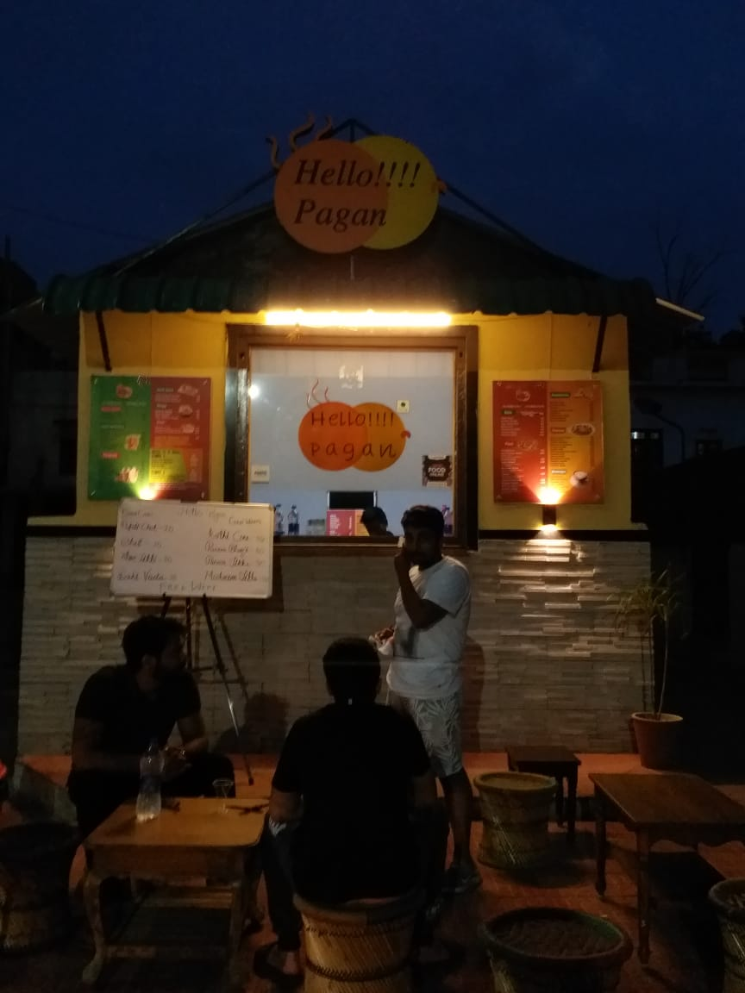

Overlooking Lake Swaroop Sagar and situated among the bustling crowd of the city, this shop has a variety of Rolls ranging from their famous Aloo Tikka Roll to Baby Corn, and Paneer Tikka Roll as well.

**Location –**8, Pratap Marg, Near Swaroop Sagar, Udaipur

**Specialty –**Veg. Kathi Roll, Aloo Tikka Roll, Paneer Tikka Roll, etc.

**Price range –** ₹69 – 109/-

**2. Biryani House**

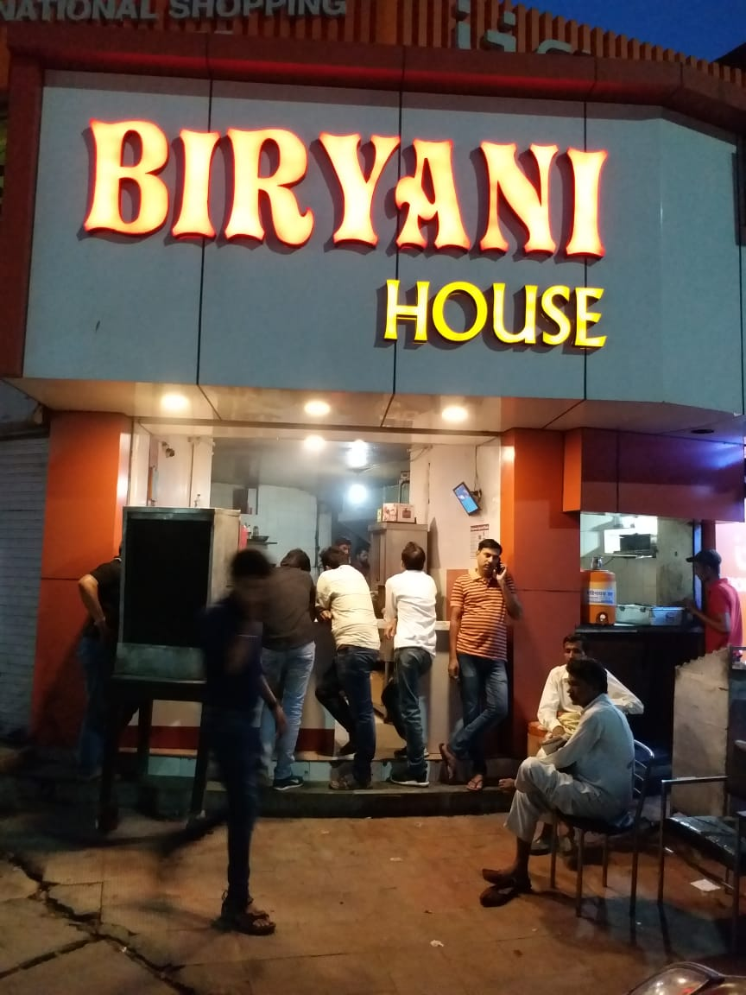

Situated in the heart of the city, this place is famous for their non-vegetarian Rolls and you might have to wait for a while to get your hands on them, sometimes.

**Location –**Opp. Apaji Petrol Pump, Chetak Circle, Udaipur

**Specialty –**Shawarma, Chicken, Keema, Egg, and Paneer Roll

**Price range –**₹90 – 140/-

**3. Rooti Wrap and Rolls**

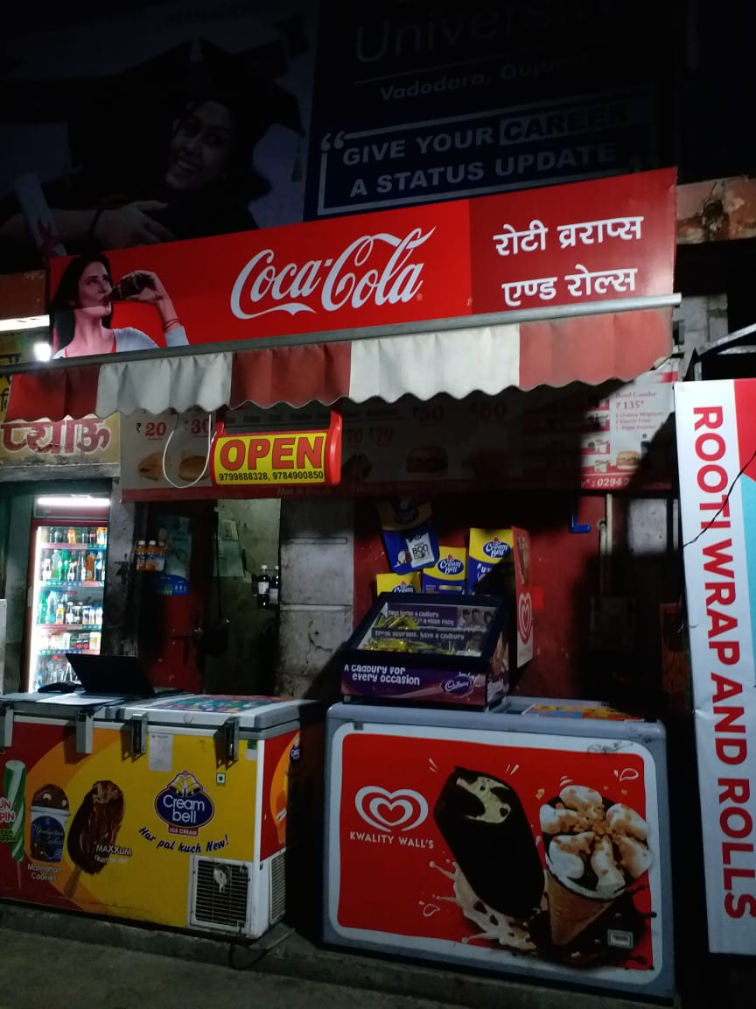

This is one of the most popular shops for some amazing Wraps. Serving a whopping 135 varieties of Wraps and Rolls, this is, without a doubt, a must-visit place.

**Location –**Pyau, Opp. Mohta Park, Pahadi Bus Stand, Chetak Circle, Udaipur

**Specialty –**Tikki Burnt Garlic Mayo, Paneer Mayo, Paneer Burnt Garlic Mayo Wrap, etc.

**Price range –**₹45 – 160/-

**4. Wrapstick**

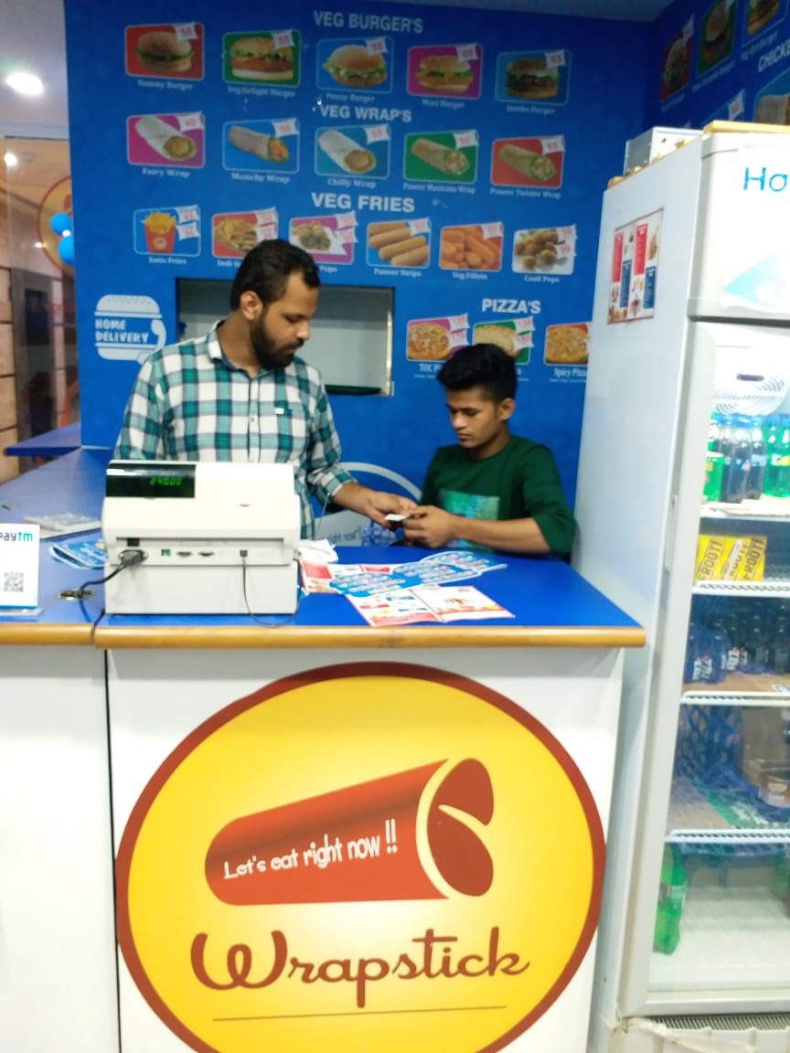

This place has a good variety of Wraps, both in veg and non-veg, at really affordable rates.

**Location –**G-3, Arvanah Mall, Hathipole, Udaipur

**Specialty –**Paneer Mexicana, Bar-B-Q, Fairy, Rocket Wrap, etc.

**Price range –**₹40 – 65/-

**5. Chicken King**

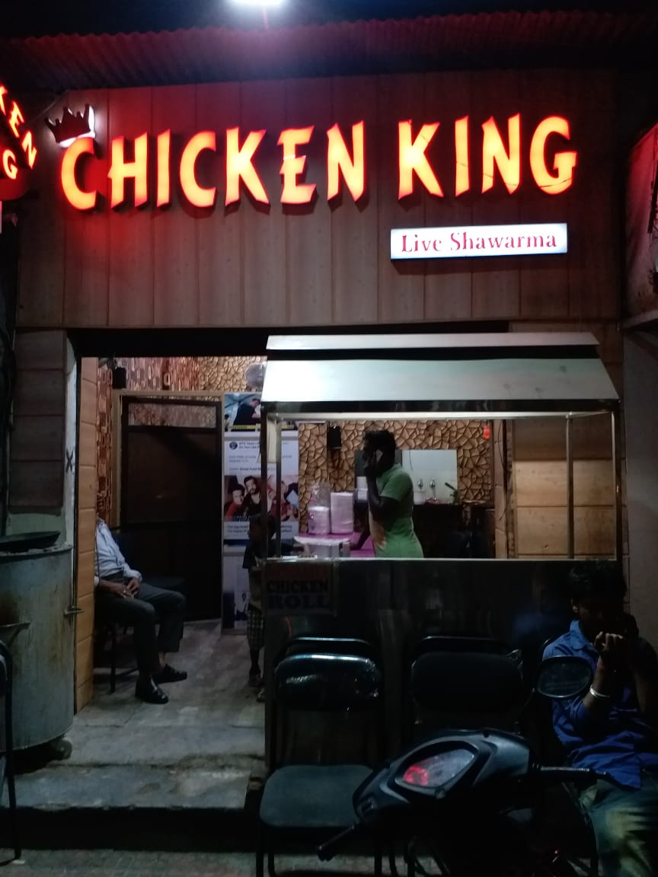

This is a lesser known place in the city as it serves just a few varieties of Rolls but is quite popular among people who are chicken fans. Visit this place soon!

**Location –**Near Delhigate Circle, Opp. Sharad Medical, Udaipur

**Specialty –**Chicken Mumbaiya Tandoori Roll, Shawarma Roll

**Price range –**₹100 – 120/-

**6. Shawarma King**

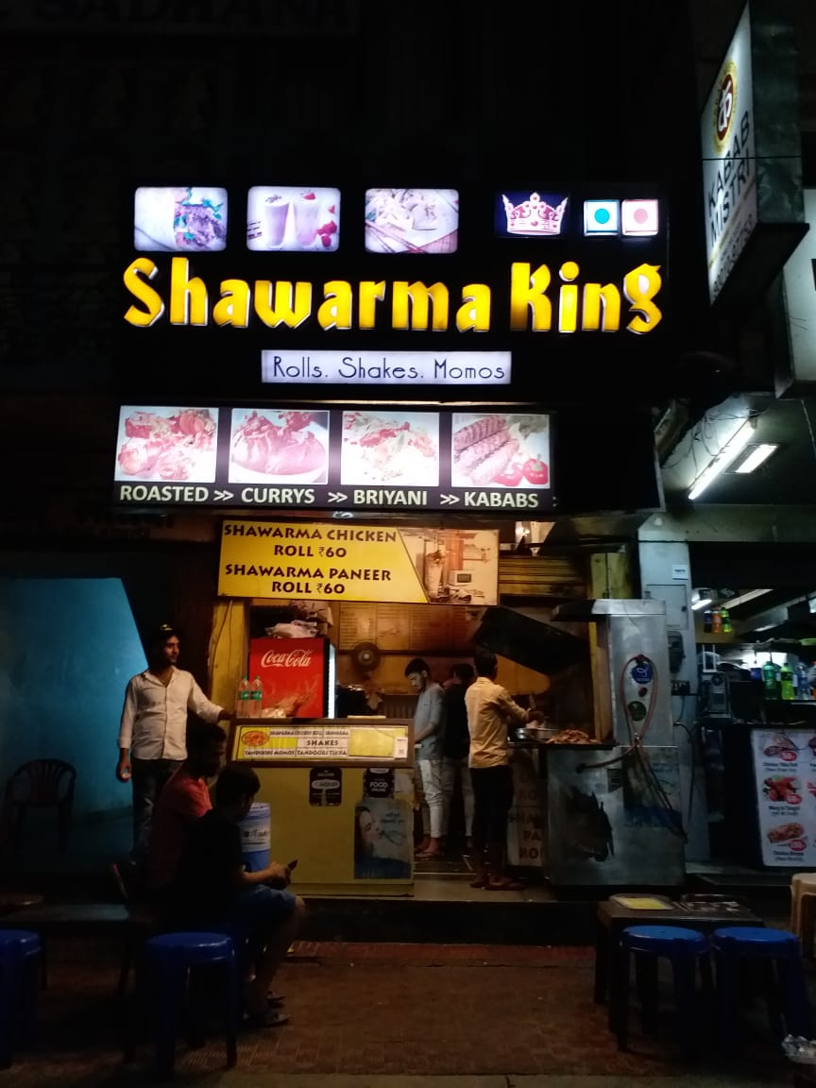

This is again one of the most popular shops in the city serving delicious varieties of Wraps and Rolls at reasonable prices.

**Location –**Shop No. 22, City Station Road, Surajpole, Near Sadhna Hotel, Udaipur

**Specialty –**Shawarma Chicken Roll, Shawarma Paneer Roll, Butter Chicken Kathi Roll, etc.

**Price range –**₹35 – 120/-

**7. Kabab Mistri**

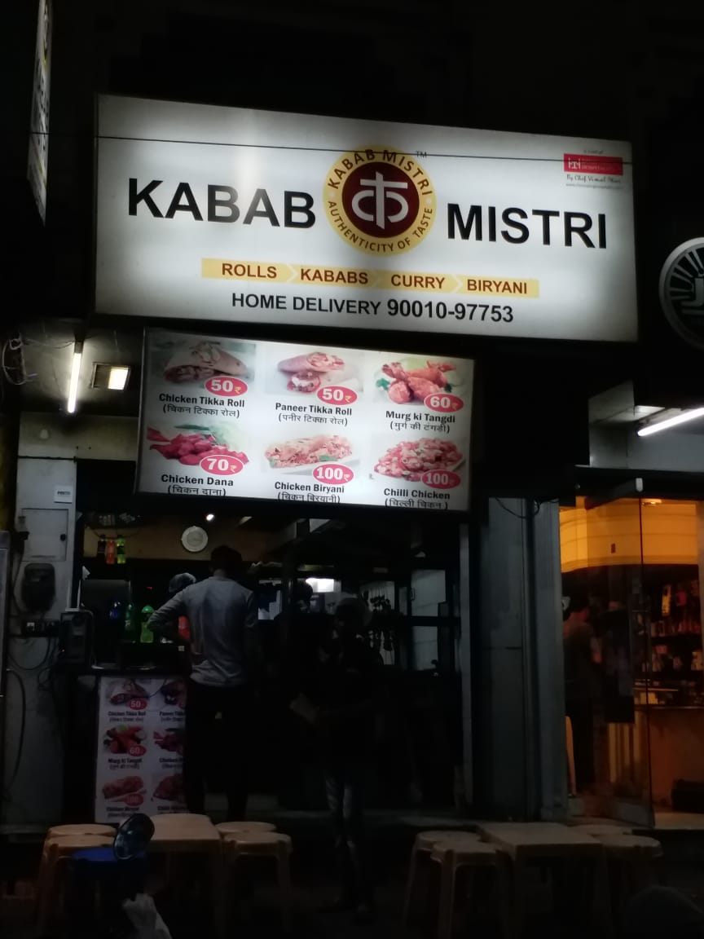

Situated right next to Shawarma King is this shop, making tasty Wraps and Rolls.

**Location –**Surajpole, Udaipur

**Specialty –**Chicken Tikka Roll, Paneer Tikka Roll, Chicken Seekh Kabab Roll, etc.

**Price range –**₹50 – 160/-

**8. Nektar**

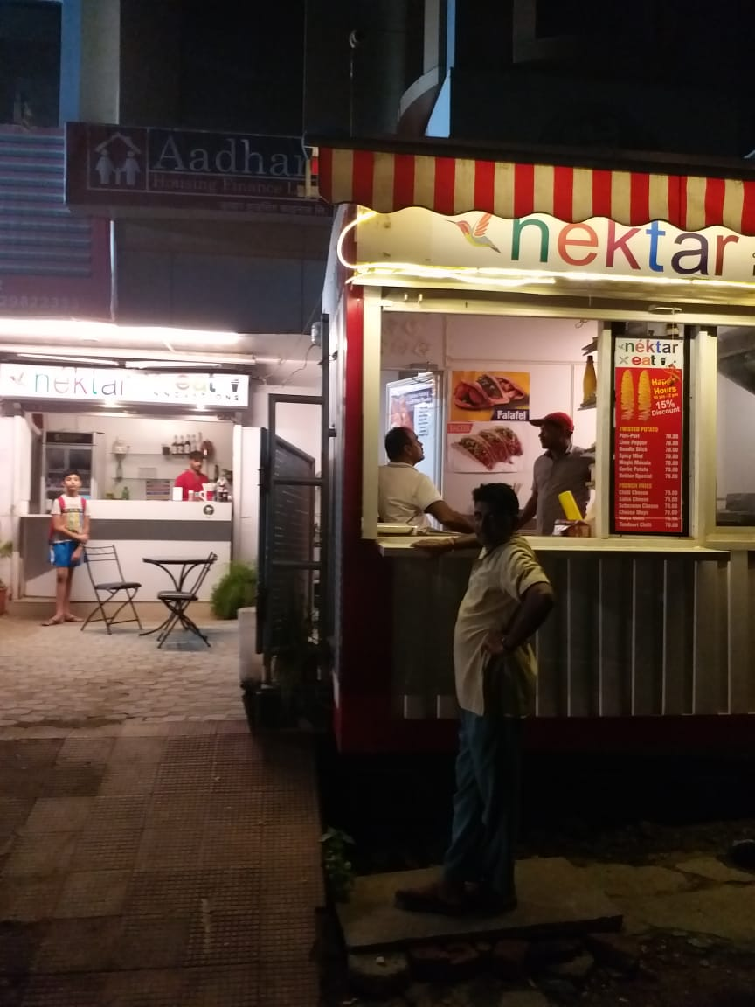

Located in the same region, famous for their Middle Eastern food like Falafels, etc., this family happily serves a variety of dishes including mouth-watering Wraps, and various other things as well. Try them out now!

**Location –**KP Arcade, UIT Circle, New Fatehpura, Udaipur

**Specialty –**Masala Cheese, Beans, and Paneer Wraps

**Price range –**₹70 – 90/-

**9. Wrap’n Go**

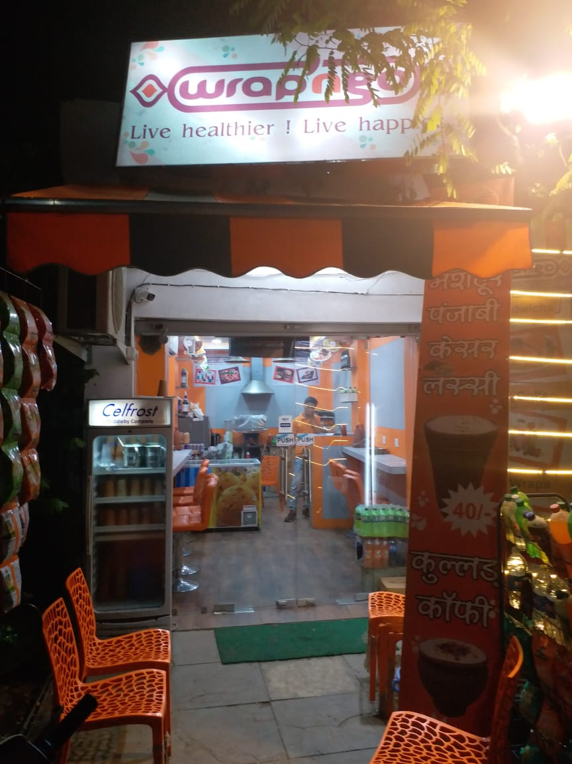

This is a recently opened shop and serves decent varieties of Wraps at affordable rates.

**Location –**Opp. Saheliyon Ki Badi, Saheli Marg, Udaipur

**Specialty –**Paneer Wrap, Veg. Wrap, Paneer Bhurji Wrap

**Price range –**₹70 – 90/-

**10. Crave Eat Repeat**

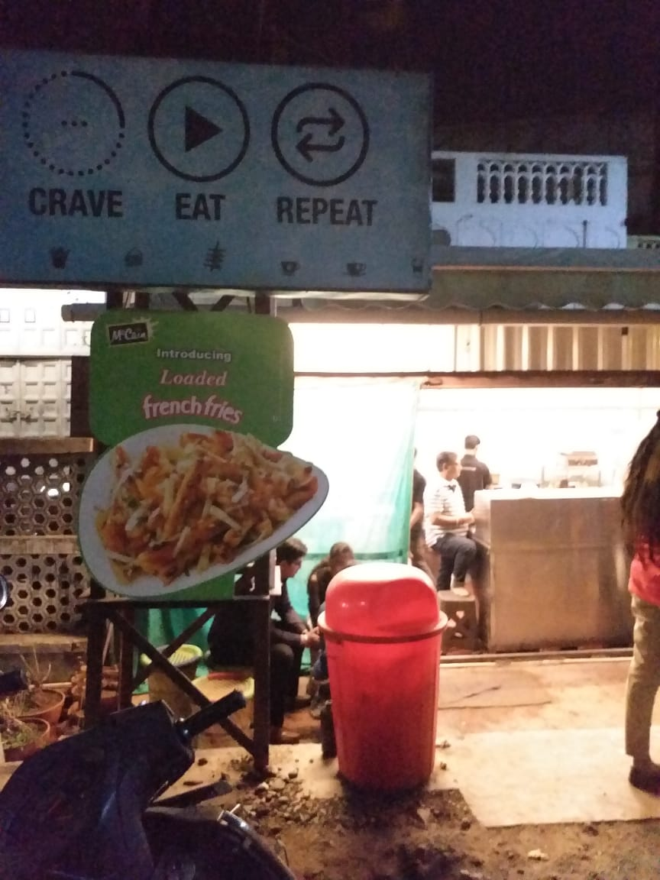

Again one of the most popular shops in town, they serve a good variety of Frankies with savory sauces.

**Location –**95, New Fatehpura, UIT Circle, Udaipur

**Specialty –**Potato Classic, Tandoori Paneer, Cheese Frankie, etc.

**Price range –**₹70 -80/-

**11. Chatkazz**

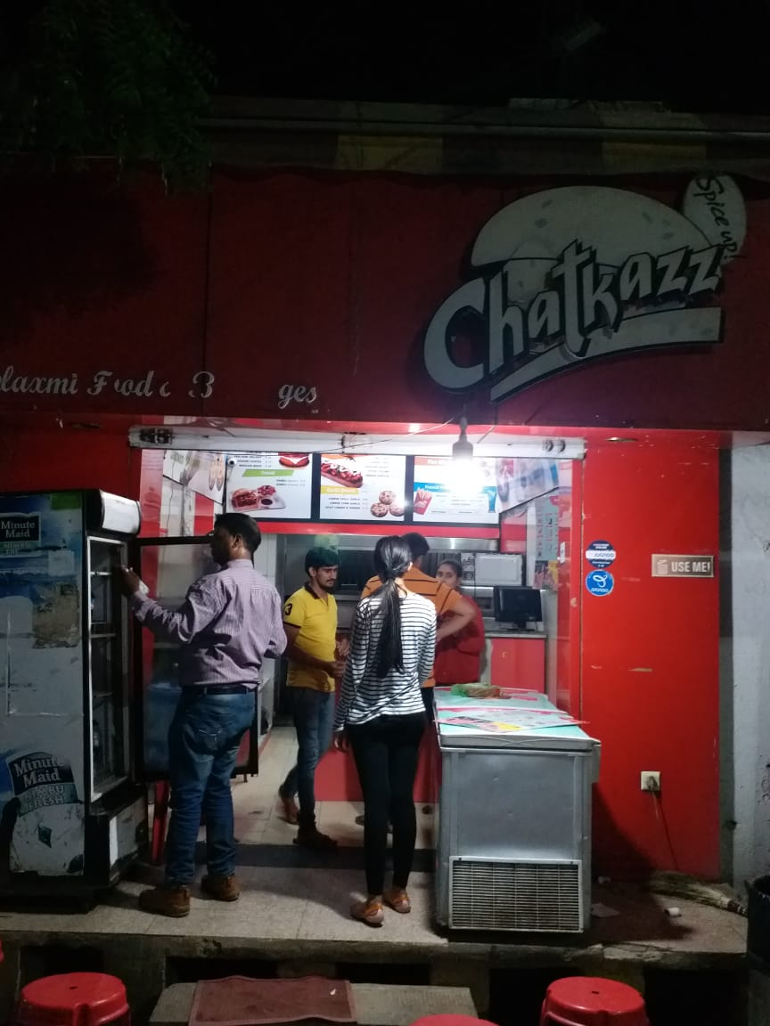

Amazed? Yes, this place has recently started serving Wraps as well. Check them out soon!

**Location –**Gumania Wala Petrol Pump, Near Miraj House, Udaipur

**Specialty –**Chatpata Kebab, Paneer Wrap, etc.

**Price range –**₹50 – 80/-

**12. Gudduz**

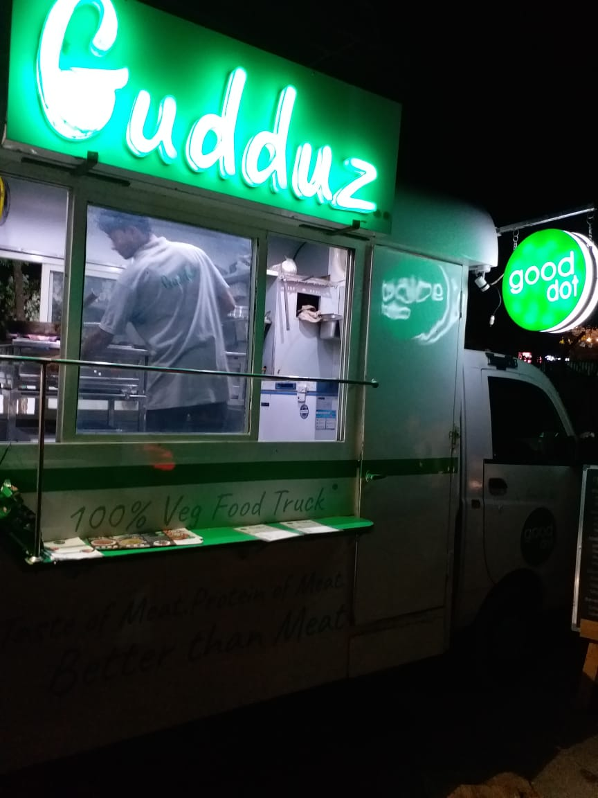

This is among the trendiest places in the city and serves amazing and new varieties of Wraps with names that’d make you wonder if they’re non-veg (they’re actually veg, though).

**Location –**Sukhadia Circle and Shobhagpura 100 ft. Road, Udaipur

**Specialty –**Proteiz Bhurji Wrap, Proteiz Chilli Wrap, Veg. Meat Wrap

**Price range –**₹50 – 75/-

**13. Roll Express**

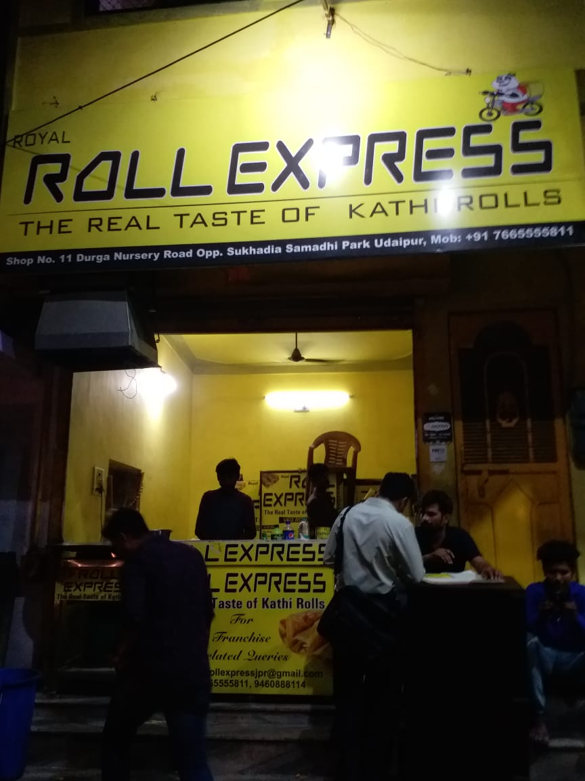

This shop in Ashok Nagar serves a wide variety of veg and non-veg Rolls, over 60 to be precise, and is quite popular among the residents of the area as well.

**Location –**Shop No. 11, Opp. Sukhadia Memorial, Durga Nursery Road, Udaipur

**Specialty –**Aloo, Paneer, Chaap, Chicken, Mutton Rolls

**Price range –**₹30 – 160/-

**14. Jumbo Vada Pav**

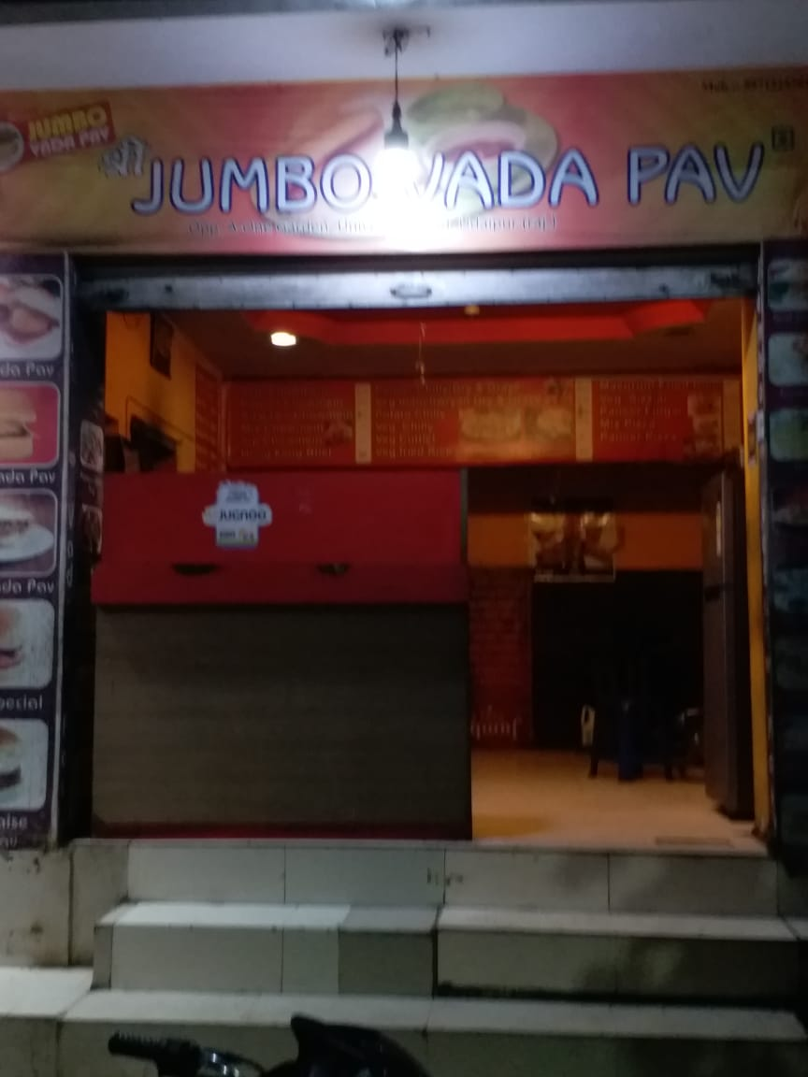

Don’t be shocked! This place serves yummy Frankies at really affordable prices. Try them out for yourself.

**Location –**University Road, Opp. A-One Garden, Udaipur

**Specialty –** Veg Cheese Frankie, Paneer Masala, Paneer Masala Cheese Frankie

**Price range –**₹40 – 70/-

*So now that you know about all the happening spots, go grab a bite at one of these places and tell us how it was in the comments section below. I would love to hear your reviews and suggestions!*

*Happy Eating!*

Facebook Comments

**Post Pagination**

* [**PREVIOUS POST**](https://www.udaipurblog.com/tourism-in-udaipur-gets-a-boost-know-about-the-developments-in-our-city.html)
* [**NEXT POST**](https://www.udaipurblog.com/wo-roti-rahi-bikhari-rahi-lekin-uski-baat-sunne-wala-koi-nahin-tha.html)

[**CHICKEN TIKKA**](https://www.udaipurblog.com/tag/chicken-tikka),[**KATHI ROLL**](https://www.udaipurblog.com/tag/kathi-roll),[**PANEER**](https://www.udaipurblog.com/tag/paneer),[**ROLLS**](https://www.udaipurblog.com/tag/rolls),[**SHAWARMA**](https://www.udaipurblog.com/tag/shawarma),[**STREET FOOD**](https://www.udaipurblog.com/tag/street-food),[**TOP**](https://www.udaipurblog.com/tag/top),[**UDAIPUR**](https://www.udaipurblog.com/tag/udaipur),[**UDAIPUR BLOG**](https://www.udaipurblog.com/tag/udaipur-blog),[**WRAPS**](https://www.udaipurblog.com/tag/wraps)

**LIKE IT? SHARE WITH YOUR FRIENDS!**

* [Facebook](https://www.facebook.com/sharer/sharer.php?u=https://www.udaipurblog.com/the-14-best-places-for-wraps-and-rolls-in-udaipur.html&t=The+14+Best+Places+for+Wraps+and+Rolls+in+Udaipur)
* [Twitter](https://www.udaipurblog.com/the-14-best-places-for-wraps-and-rolls-in-udaipur.html)

[](https://www.udaipurblog.com/author/akshat)

Posted by[**Akshat Khamesra**](https://www.udaipurblog.com/author/akshat)

'The more you sweat in peace, the less you bleed in war'- Norman Schwarzkopf